# STRUCTURE OF A WEB BROWSER

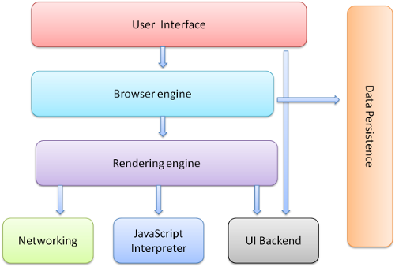

The main components of the web browser as mentioned in the above diagram are explained briefly.

**User Interface:**  This includes the address bar, back/forward button, bookmarking menu, etc. Every part of the browser display except the window where you see the requested page.

**Browser Engine:** Browser engine is the main software tool component of a web browser which is also called as layout engine. The main use of this is to co-ordinate actions between the UI and rendering engine.

**Rendering Engine:** The main use of this engine is to convert HTML documents and other resources of a web page into interactive visual representation on a user’s device. By default rendering engine can display HTML and XML documents and images. The rendering engine will start parsing the HTML document and convert elements to DOM nodes of content tree. Styling information together with visual instructions in the HTML will be used to create another tree called render tree.

**Networking:**  for network calls such as HTTP requests, using different implementations for different platform behind a platform-independent interface.

**UI backend**: used for drawing basic widgets like combo boxes and windows. This backend exposes a generic interface that is not platform specific. Underneath it uses operating system user interface methods.

**JavaScript interpreter**: Used to parse and execute JavaScript code.

**Data storage**: This is a persistence layer. The browser may need to save all sorts of data locally, such as cookies. Browsers also support storage mechanisms such as localStorage, IndexedDB, WebSQL and FileSystem.